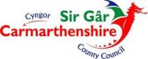
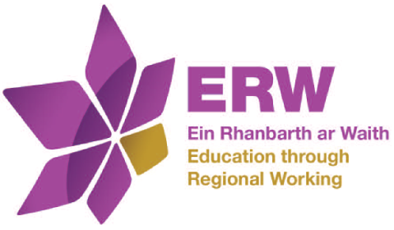
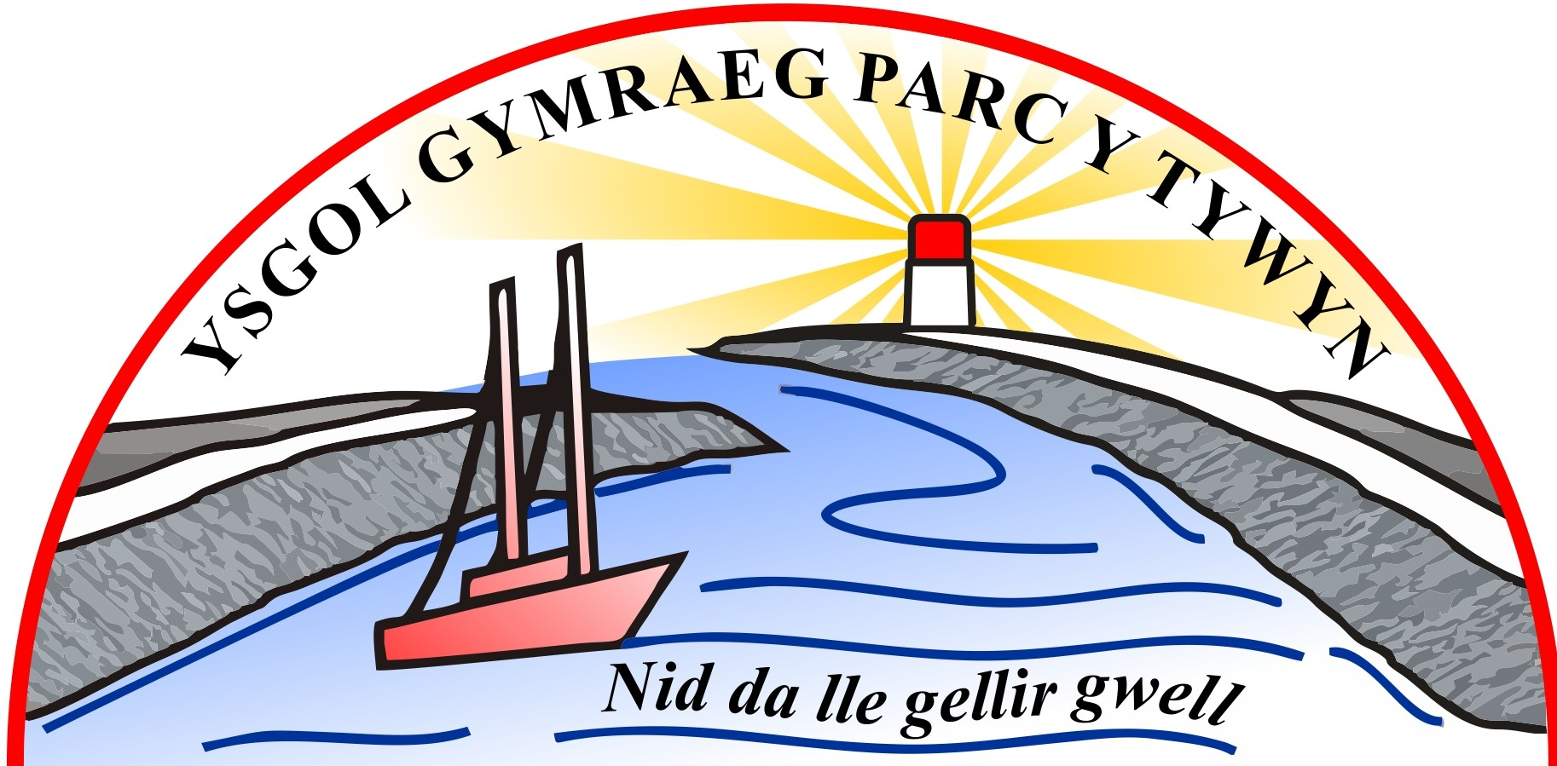

Ysgol Gymraeg Parc y Tywyn School PDG Statement 2019-20
The Pupil Deprivation Grant (PDG) is allocated to schools with pupils who come from low-income families and are currently known to be eligible for free school meals (e-FSM) and pupils who have been looked after continuously for more than six months (LAC).
Schools are expected to make the best use of this funding to implement sustainable strategies that will quickly bring about changes for learners eligible for free school meals or who are LAC.
As a school we have agreed the following three steps:

- to identify the target group of pupils, its characteristics and needs
- to plan interventions which make the most effective use of resources
- to monitor and evaluate the impact of resources

In 2019-20 Ysgol Gymraeg Parc y Tywyn was provided with a PDG allocation of £34,550.
At Ysgol Gymraeg Parc y Tywyn we have a comprehensive plan, agreed and monitored by Carmarthenshire Local Authority and ERW, to promote progress and remove barriers to learning for students eligible for this funding.
We have used the funding available to:
- employ staff that can provide intervention and support programmes that will raise the standards of attainment of the pupils.
- provide intervention and support programmes that are proven to have the greatest impact and to be sustainable- ‘ELSA’, numeracy and positive play
- implement Restorative Practice within the school as a means to develop relationships and impact on behaviour.
- 25% reduction of FSM families on residential courses
- Multimedia workshop with CISP
Our detailed plan which includes details in respect to how we’re spending the grant is available at the school.

