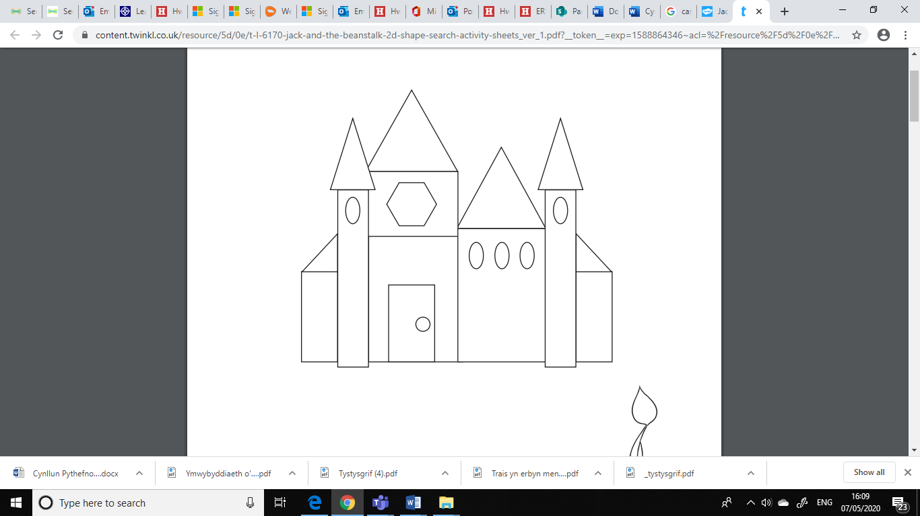 | I wneud fy nghastell, defnyddiais _______ cylch _______ sgwar  ________hecsagon ac ati

