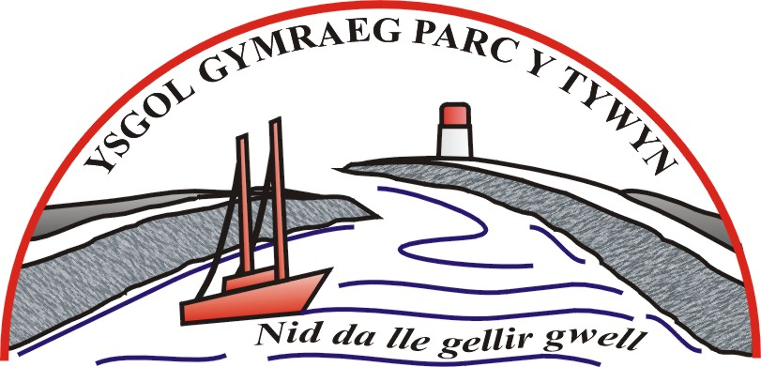
Heol y Bardd, Porth Tywyn,
Sir Gaerfyrddin SA16 0NL

Ffôn:- 01554 832101
Ebost: admin@parcytywyn.ysgolccc.org.uk
www.ysgolparcytywyn.co.uk
Pennaeth: Mr Craig Davies

Ysgol Gymraeg Parc y Tywyn
0

11th October, 2018

Dear parent/guardian,

Ysgol Gymraeg Parc y Tywyn and Ysgol Pum Heol are organising a trip to the Wimbledon Tennis Championships and Indoor Snowdome on Monday 1st of July until Tuesday 2nd of July 2018. Play is scheduled for matches on the opening day of the championship. We will also be visiting the Indoor Snowdome at Hemel Hempstead for a 1 ½ hour skiing lesson as well as 30 minutes’ fun session on the Ringo Slide.

https://www.thesnowcentre.com

The price of the trip is around £180 per person (dependant on numbers).

The price includes:
• Two days’ coach travel.
• One night’s accommodation at a three-star hotel.
• Continental breakfast.
• One day admission to a No.2/No.3 Court ticket for The Championships.
• Half-day at the Indoor Snowdome in Hemel Hempstead.

If you would like to reserve a place please complete the slip below and return it with a £50 non-refundable deposit to the school by Thursday, October 25th 2018.

PLEASE NOTE: THERE ARE ONLY 30 SPACES AVAILABLE THEREFORE WE CAN ONLY RESERVE A PLACE ON A FIRST COME FIRST SERVE BASIS.
Please make all cheques payable to ‘Ysgol Gymraeg Parc y Tywyn’.

Yours faithfully,
Mr. C. Davies
-------------------------------------------------------------------------------------------------------
Amgaeaf blaendâl na ellir ei ad-dalu o £50 ar gyfer y daith i:
I enclose a £50 non-refundable deposit for the trip on behalf of:

Enw/ Name:…………………………………………… Dosbarth/ Class:………………....

Llofnodwyd/ Signed:…………………………………. Dyddiad/ Date:……………………

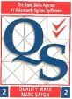
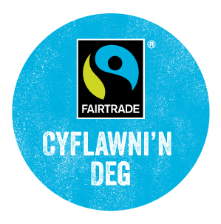
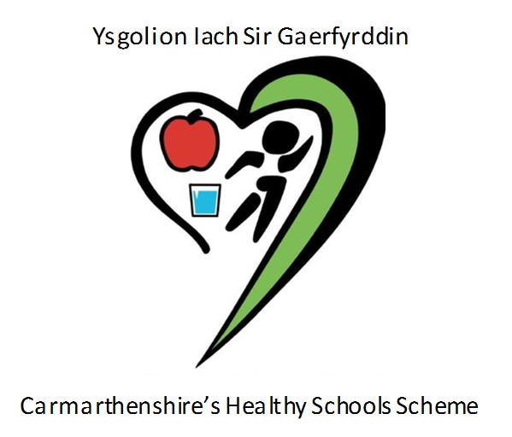

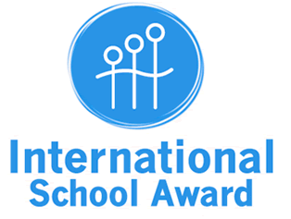


Pennaeth: Mr Craig Davies

